Topic:
- Operators in SQL*Plus
- Functions: Single Row and Group Functions

EXERCISE 3: Operators and Functions

Aim: To understand different operators and types of functions in SQL. Execute the following queries based on the schema specified in exercise 1.

Q1. Find the female employee names having salary greater than Rs.25000.
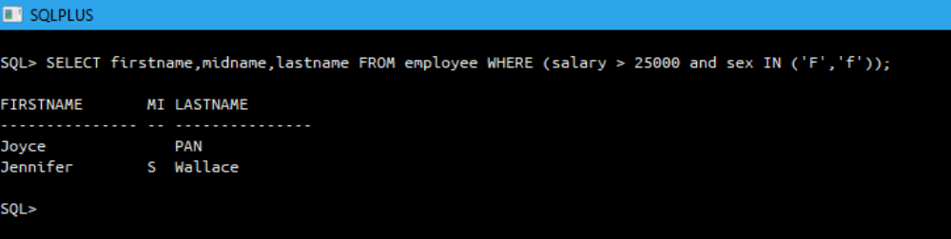

Q2. Find the employee names whose salary falls in the range of 30000 and 70000.
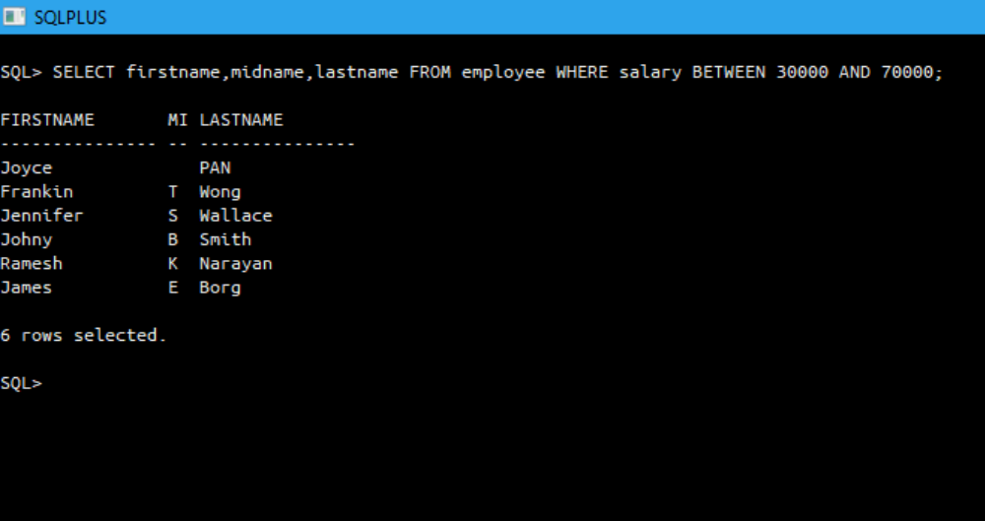

Q3. Find all the employees who have no supervisor.
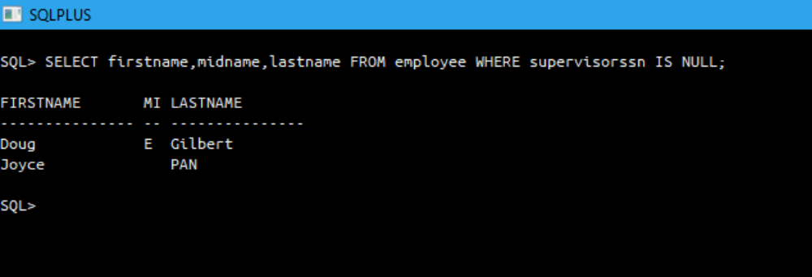

Q4. Display the bdate of all employees in the format ‘DDthMonthYYYY’.
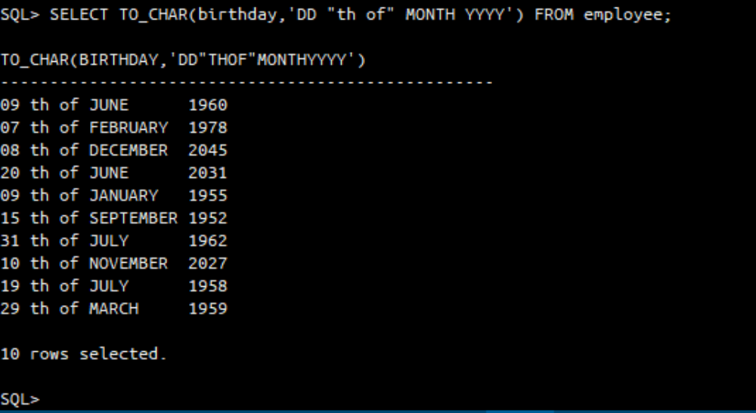

Q5. Get the employee names whose bdate not later than 1978.
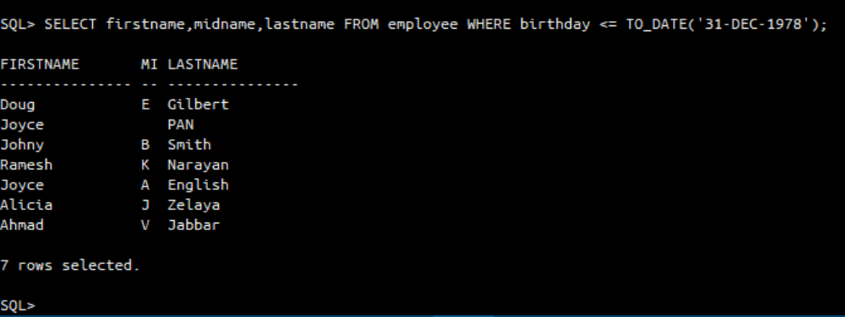

Q6. Retrieve the employee names whose first name start with ‘J’ and have 5 characters in total.
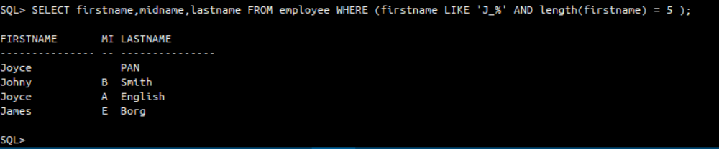

Q7. Find the employee details whose middle initial is null.
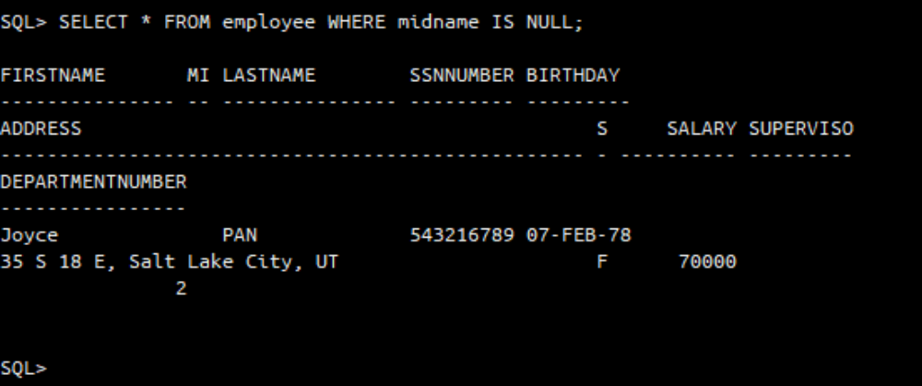

Q8. Get the male employee details whose address contains sub string ‘Houston’.
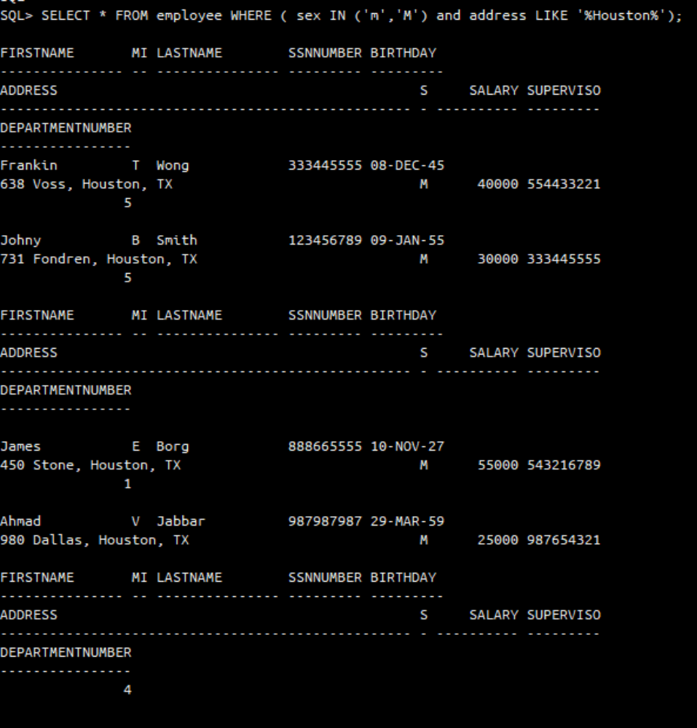

Q9. Display the department names that ends with ‘e’.
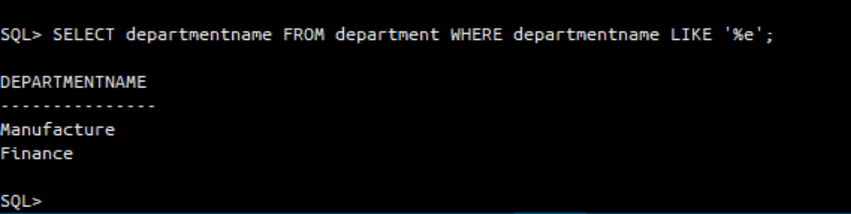

Q10. Display the names of all the employees having supervisor with any of the following SSN: 554433221, 333445555.

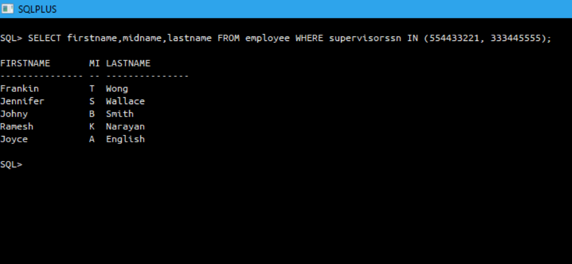

Q11. Display all the department names in upper case and lower case.
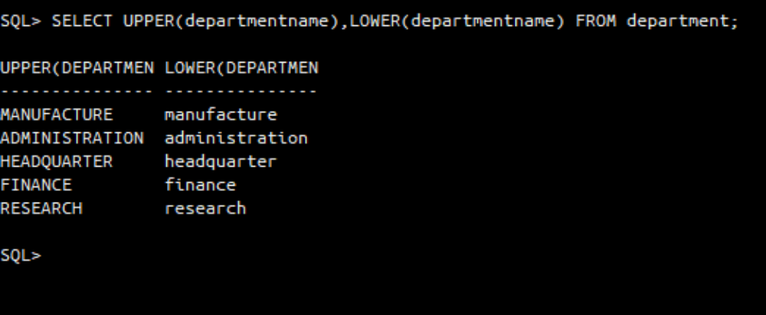

Q12. Display the first four characters and last four characters of the department names using substring function.
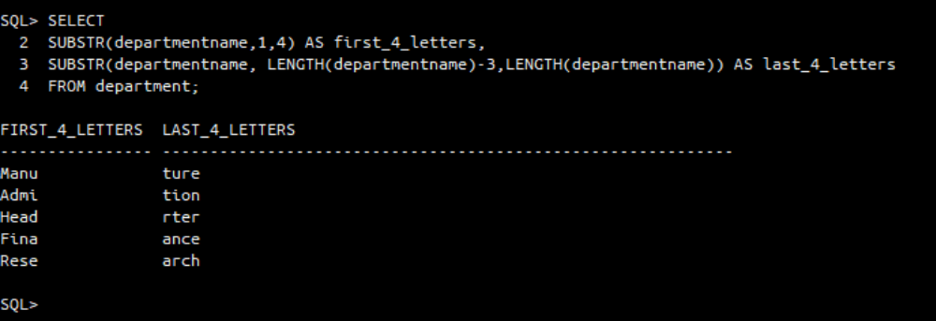

Q13. Display the substring of the address (starting from 5th position to 11 th position) of all employees.
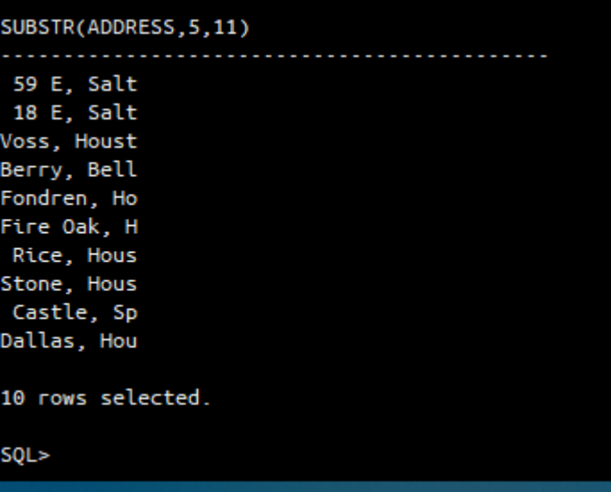

Q14. Display the Mgrstartdate on adding two months to it.
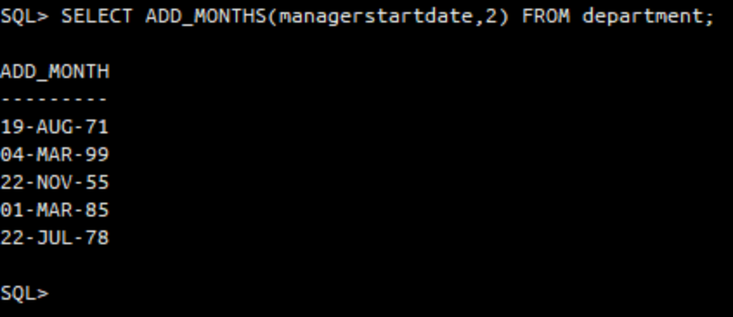

Q15. Display the age of all the employees rounded to two digits.
Note: ROUND() function: used to round the ages to two digits
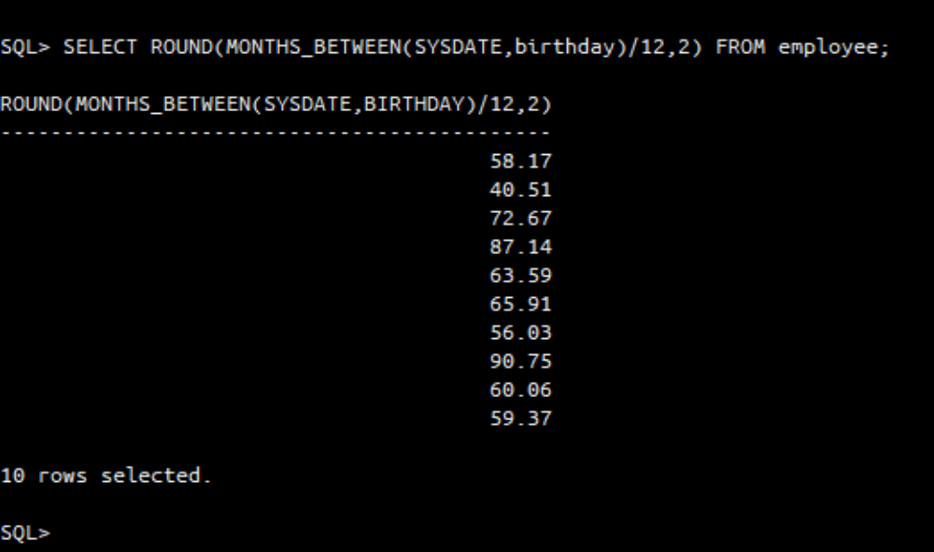

Q16. Find the last day and next day of the month in which each manager has joined.
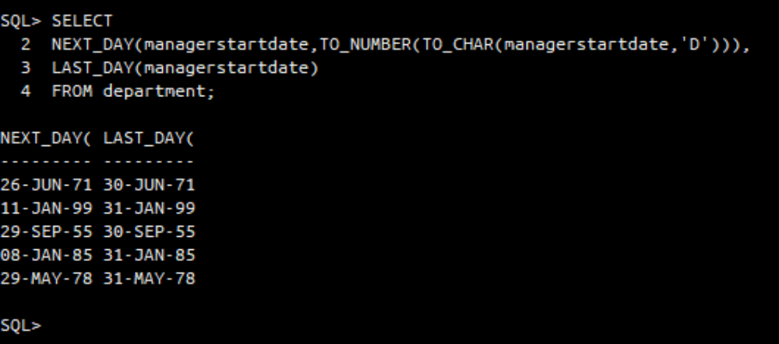

Q17. Print a substring ‘aman’ from the string ‘Ramana’.
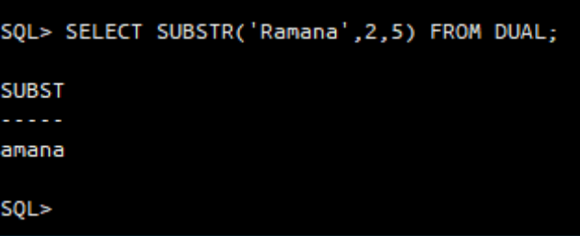

Q18. Replace the string ‘na’ from ‘Ramana’ by ‘sri’.
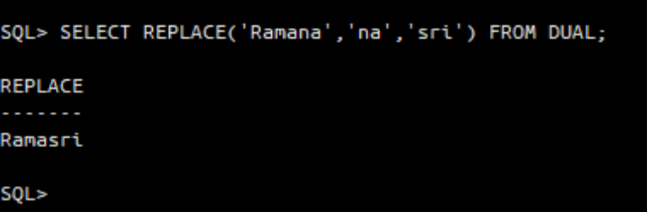

Q19. Print the length of all the department names.
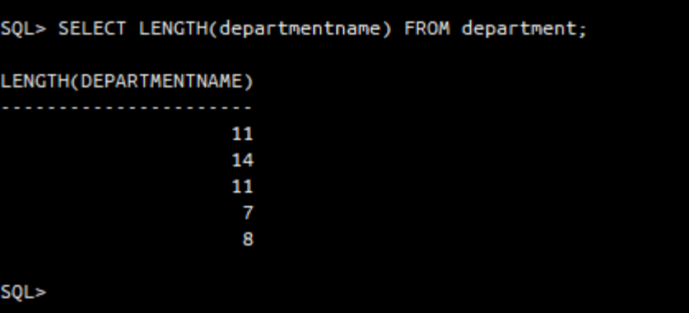

Q20. Print the system date in the format 25 th May 2014.
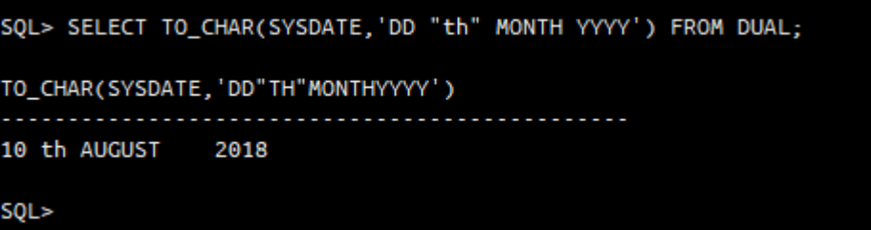

Q21. Display the date after 8 months from current date.
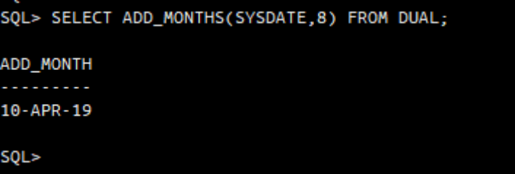

Q22. Display the next occurrence of Friday in this month.
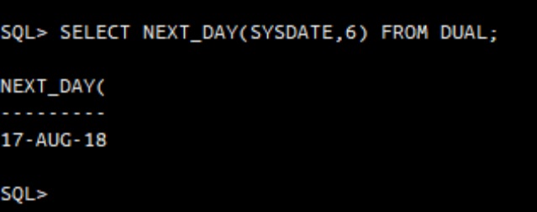

Q23. Display the project location padded with **** on left side.
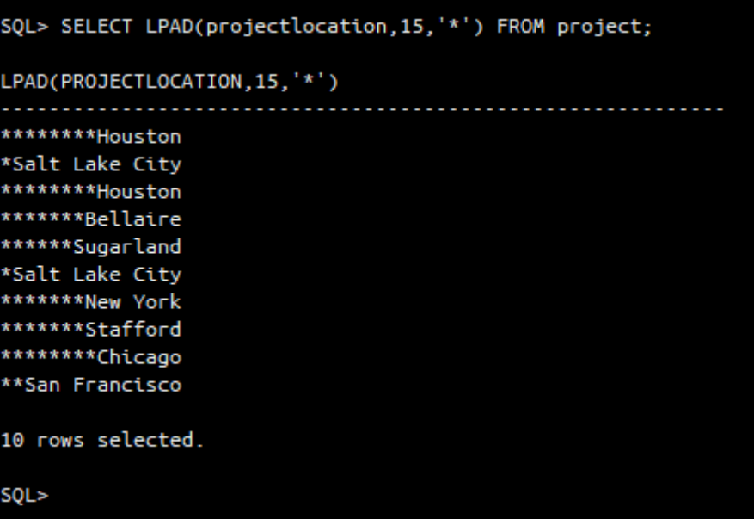

Q24. Remove the word ‘Project’ from the project name and display it.
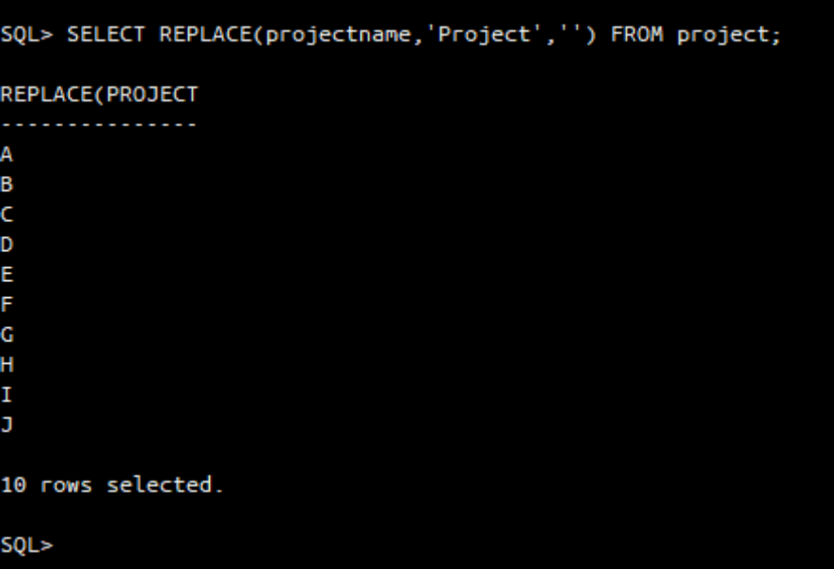

Q25. Select the SSN of the employee whose dependent name is either Michael or Abner.
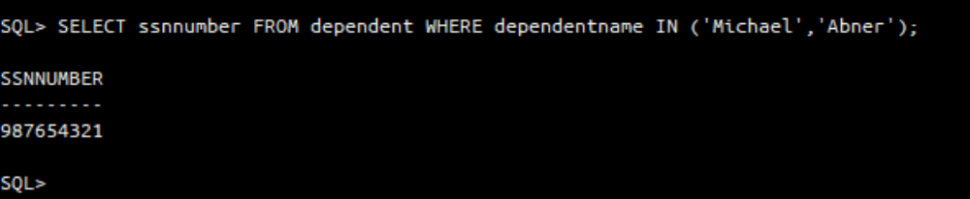

End of Exercise 3

[View next page]

EXERCISE 4: Group Functions

Aim: To understand group functions in SQL. Execute the following queries based on the schema continued from exercise 3.

Q1. How many different departments are there in the ‘employee’ table.
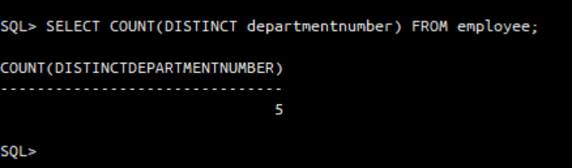

Q2. For each department display the least and highest employee salaries along with department name.
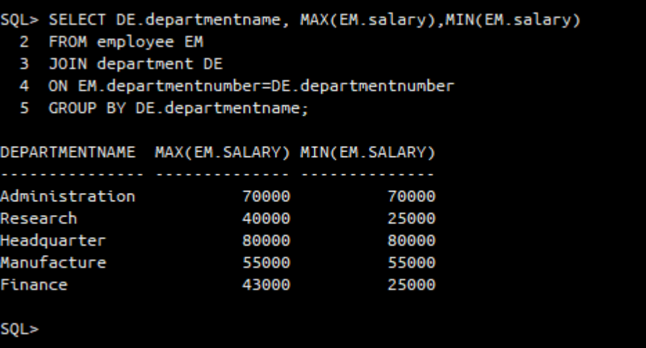

Q3. Print the number of projects on which each employee is working on.
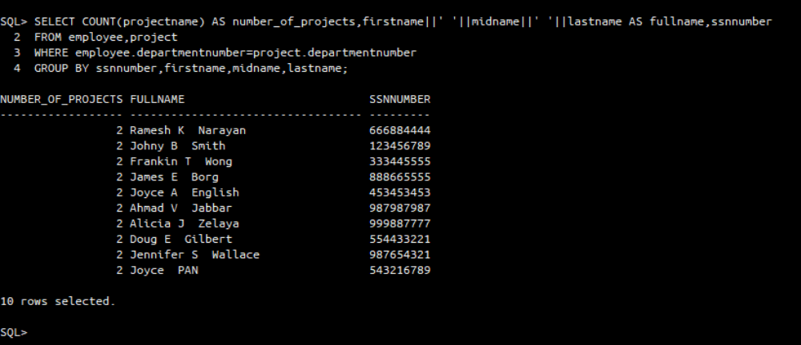

Q4. Retrieve total number of hours spent on projects by each employee.
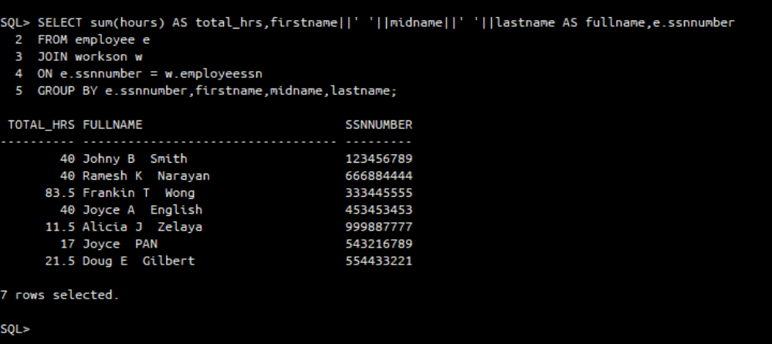

Q5. Count the number of employees over 30 age.
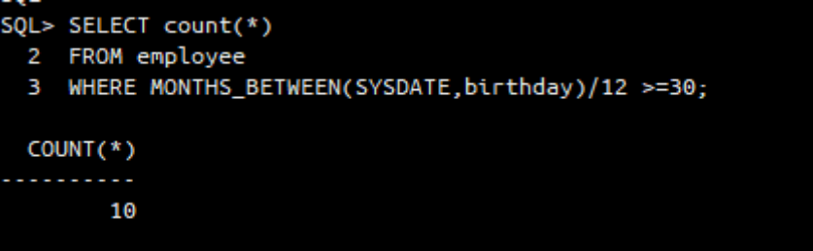

Q6. Display the department name which contains more than 3 employees.
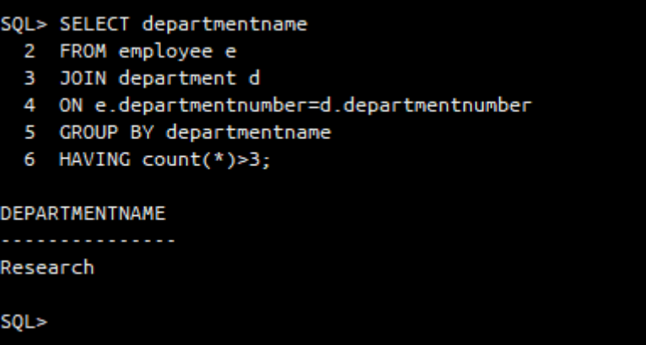

Q7. Calculate the average salary of employees by department and age.

Average salary by department:
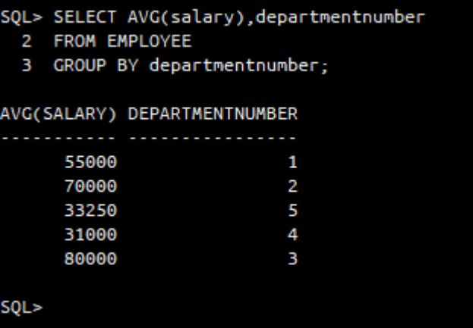

Average salary by age:
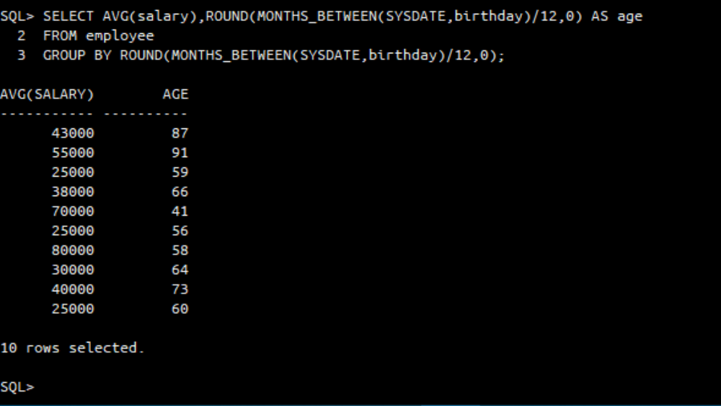

Q8. Count the number of dependents for each employee.
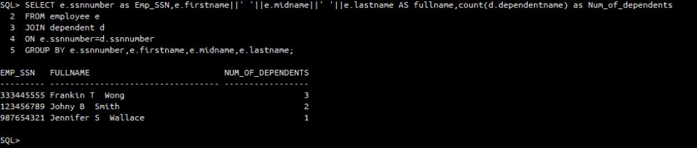

Q9. List out the employees based on their seniority.
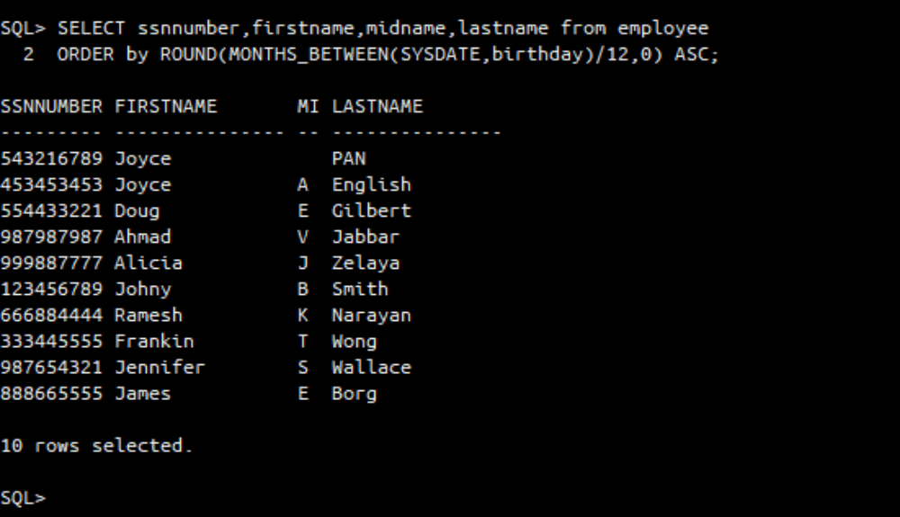

Q10. List out the employees who works in ‘manufacture’ department group by first name.
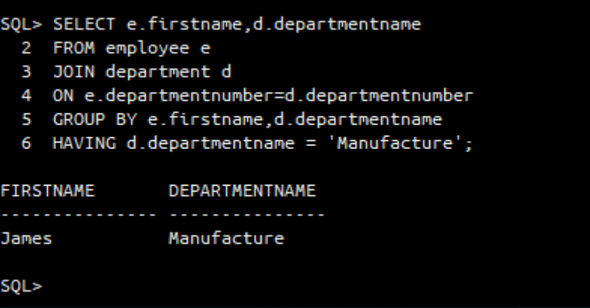

End of Assignment 2

